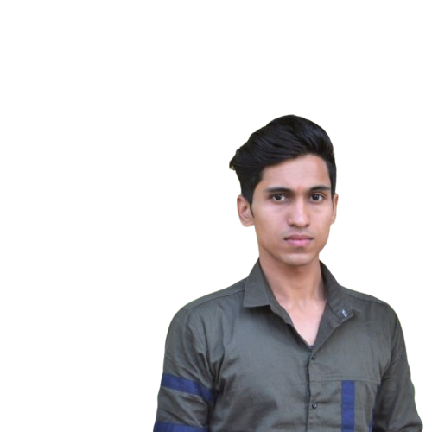 |  | varun tiwri  FRESHER
Profile  Motivated and responsible Computer Science student with a specialization in Data Science and Artificial Intelligence. Passionate about solving complex problems and building efficient software systems. Skilled in programming, data handling, and technical support, with a proactive and collaborative work ethic.  Contact  PHONE:  +91 7860416963  WEBSITE:  www.linkedin.com/in/varun-tiwari-252271253  EMAIL:  Mr.varun018@gmail.com  Technical Skills  - Programming (Python, Java basics)  - Data Structures and Algorithms  - Web Development  - Software Re-Engineering  - Artificial Intelligence Tools  - Optimization Methods  - Graphical Representation & Reporting  - MS Office, Typing, System Boot Management |  | EDUCATION  Bachelor of Computer Applications (BCA) – Data Science & Artificial Intelligence  BBD University, Lucknow, India  2023 – 2025 | CGPA: 6.68  Senior Secondary Certificate (12th Grade)  Kendriya Vidyalaya, Lucknow, India  2021 – 2022 | Commerce + Informatics Practices | 74.4%  Secondary School Certificate (10th Grade)  Kendriya Vidyalaya, Lucknow, India  2019 – 2020 | 64%  WORK EXPERIENCE  Technical Support & Backend Developer  Danbro by Mr. Brown – Lucknow, India  Provided technical support for backend systems; assisted in maintaining web applications and resolving software issues.  Intern – Big Data & Networking  IBM (Virtual Internship)  Worked on real-time big data use cases, data processing, and basic networking concepts.  Sales Manager  London Bubble Franchise(café) – Lucknow, India  Managed sales and customer engagement, improved team efficiency and customer satisfaction.  SKILLS  Communication  Leadership  Teamwork  Resource Management  Languages  - Hindi – Native  - English – Fluent

