SHABBEER HUSEN 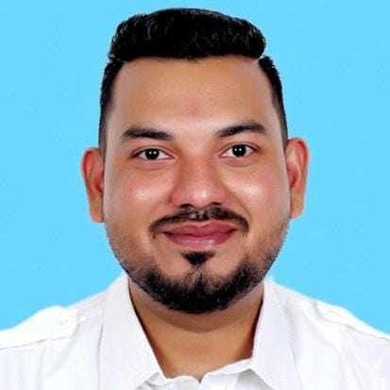
Bodyshop Manager
📍 105 Siddhivinayak Apartment, Alkapuri, Achole Road, Nalasopara, Maharashtra – 401209
📧 shabbirzaidi17@gmail.com | 📞 +91 7045692403 , 90043 90997

Professional Summary
Highly accomplished Bodyshop Manager with over 10 years of progressive experience in leading authorized service centers (Maruti Suzuki & Toyota). Expert in Bodyshop operations, insurance claim handling, productivity improvement, and team management under Toyota Service Management (TSM) & Maruti Suzuki service Management standards.
Recognized for consistently achieving Customer Satisfaction Index (CSI) targets, maintaining OEM quality standards, and enhancing workshop profitability through Kaizen process improvements and strong leadership.

Core Competencies
Toyota Service Management (TSM) Implementation
Bodyshop Operations & Production Control
Insurance Claim Management & Coordination
Team Leadership & Staff Performance Monitoring
Kaizen & Continuous Process Improvement
Quality Control & Repair Standard Compliance
Workshop Efficiency & Throughput Optimization
Customer Satisfaction & Retention Strategies
Cost Control & Revenue Growth
OEM Audit & Policy Compliance

Professional Experience
MADHUBAN TOYOTA PVT. LTD (Toyota Authorized Service Canter)
Body shop Manager | 2024 – Present | Reay Road & Worli
Lead the Bodyshop Division with a team of 54 employees, ensuring OEM-quality repairs and monthly throughput of 350+ vehicles.
Implemented Toyota TSM principles in workflow, documentation, and customer handling for improved service efficiency.
Conducted daily process audits and Kaizen reviews to enhance productivity, reducing cycle time by 15%.
Coordinated with insurance companies and surveyors for faster claim approvals and improved cash flow.
Conducted training for advisors and technicians to align with Toyota repair standards and safety protocols.
Achieved a Customer Satisfaction Index (CSI) above 90% consistently by maintaining high-quality repair and timely delivery.

Sai Service - Bodyshop Manager (Maruti Suzuki Pvt. Ltd. )
November 2022 - 2024, Vasai
Managing a team of 30 employees in the body shop department with a throughput of minimum 220 vehicles per month.
Lead and manage all operations within the Bodyshop, overseeing a team to ensure high- quality vehicle repairs and customer service while ensuring profitability.
Implement strategic initiatives to enhance productivity, efficiency, and service quality, resulting in increased customer satisfaction and loyalty.
Coordinate with insurance companies, manage estimations and approvals, and ensure compliance with industry standards and safety regulations.

Sai Service Pvt. Ltd. (Maruti Suzuki Authorized Service Center)
Bodyshop Advisor | March 2019 – June 2022 |Borivali Mumbai
Prepared detailed repair estimates, damage assessments, and insurance documentation as per OEM procedures.
Monitored vehicle repair progress to ensure delivery within Maruti Suzuki 2/5/8-approved timelines.
Assisted customers with claim processes, technical clarifications, and feedback follow-ups.
Improved repair accuracy and reduced rework percentage through strict adherence to Maruti Suzuki repair protocols.
Managed spare parts requisition, storage, and verification aligned with paint material control systems.

Shivam Autozone Pvt. Ltd. ( Maruti Suzuki Service Zone )
Bodyshop Advisor | June 2017 – February 2019 | Kandivali Mumbai
Delivered clear communication to customers regarding repair needs and cost estimates.
Managed daily workflow scheduling, ensuring smooth operations between floor technicians and advisors.
Achieved consistent on-time delivery rate above 90% through effective coordination.
Ensured compliance with Maruti suzuki bodyshop quality, documentation, and safety standards.

Education
Diploma in Automobile Engineering
I.B.M.S, Gujarat University | Grade: 67%
Higher Secondary Certificate (H.S.C.)
Mahakoshal Vishwavidyalaya, Jabalpur (M.P.)

Certifications
Maruti Suzuki & Toyota Certified Body Paint Process Management
TSM & Kaizen Workshop Leadership Training
Insurance Claim & Process Improvement (Maruti Suzuki / Toyota)
Customer Handling Excellence – Toyota Motor Corporation

Technical Skills
Software: MS Office (Word, Excel, PowerPoint, Outlook), AutoCAD, Photoshop
Workshop Tools: Maruti Suzuki & Toyota DMS, T-Serve, CRM, Estimation Software,insurance company portal.
Expertise: Insurance Process, Body Repair Planning, Quality Auditing, Delivery Management
Languages
Hindi | Marathi | English |
Personal Traits
Strong leadership and communication skills
Excellent multitasking and decision-making ability under pressure
Positive, confident, and collaborative team player
Passionate about Toyota Quality, Customer Experience, and Continuous Improvement
Hobbies: Gaming, Riding, Listening to Music

Declaration

I hereby declare that all information provided above is true and accurate to the best of my knowledge.

Signature: ______________________
Date: __________________________

