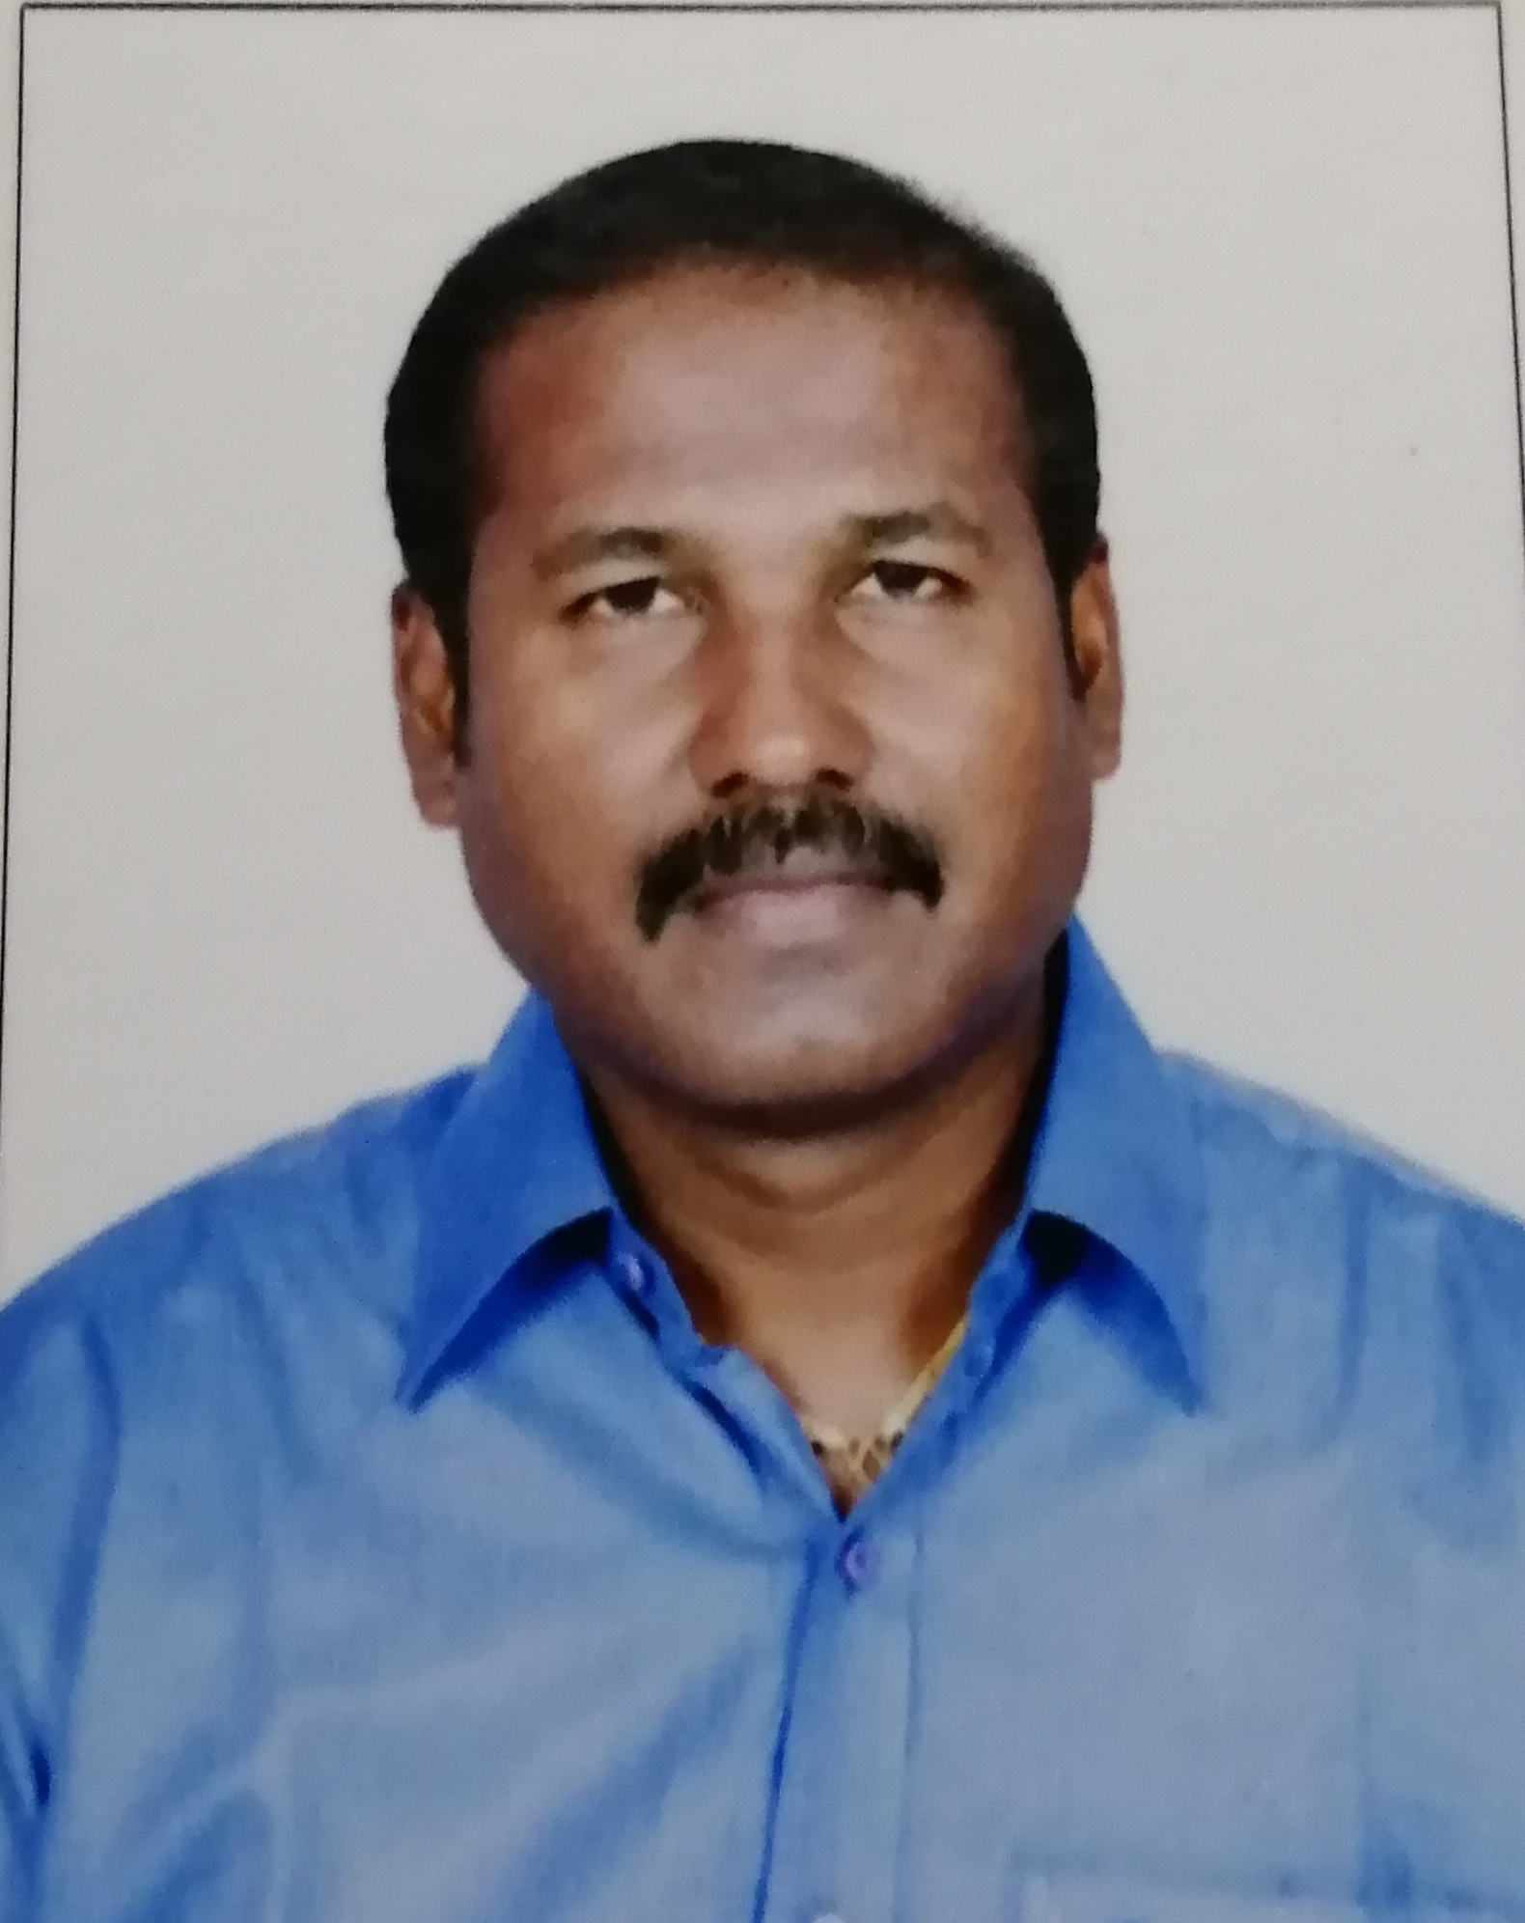

*Arul Anand*

**Objective** Hardworking Automobile professional with excellent communication skills; looking for an opportunity requiring innovation and challenge which will utilize my education and professional skills and offer growth. (Email Id – [b.arulanand807@gmail.com](mailto:b.arulanand807@gmail.com) )

**My contact number: 0091 9962428053**

**MY ACHIEVED WORK EXPERIENCE:**

**AIE CARS PVT LTD,**

**Maruti Suzuki Passenger Car Dealer, Jan 2024 – Feb 2025**

**Neelankarai, Chennai**

**General Manager Service**

* Heading the Entire Service Business Operations and Service Quality performance of Three Branches
* Managing the team of 150 – 200 employees in all 3 branches
* Focused on Operations KPI and Business KPI through the daily service operations
* Establishing long term goals as well as quarterly and annual business objectives and developing high quality business strategies and plans to deliver these.
* Managing the P&L and driving the business toward the achievement of business objectives.
* Ensuring that the Company's operations are consistent with its overall strategy and mission and fostering a strong organizational culture in line with the company's values.
* Hiring and coaching passenger cars service as well as product development teams towards high performance and engagement.
* Representing the Company with clients, investors and business partners.

**HARSHA TOYOTA Pvt Ltd,**

**Toyota Passenger Cars Dealer, March 2022 – Jan 2024**

**CHENNAI**

**General Manager Service**

* Heading the Entire After SalesService Business Operations of Two Branches
* 3S Facility Service &Bodyshop unit around 100 employees
* Satellite facility with the strength of 50 employees
* Maintain &Strengthen the Toyota Standard process and drive the team through TKM SOP.
* Main task focused on Brand standard, Revenue & Employees performance
* Review the team on the KRA’s and Revenue performance monthly
* Monitor the Business Kpi’s given to the team
* Setting the business plan to the service operations monthly
* Strong knowledge of front end dealership operations
* Substantial understanding of budgetary procedures
* Good customer and employee communications skills
* Implemented effective customer service procedures to encourage positive feedback.
* Greeted customers and responded to customer inquiries.
* Maintained inventory records of all vehicles available in Backlog list
* Worked with promotions team to develop new marketing strategies.
* Hired and trained new service staff and implemented a mentoring program
* Evaluated performance of service staff with weekly feedback.
* Planned and approved service promotions.
* Made arrangements for vehicle deliveries as per the ageing report

**HANSFORD,**

**Ford Passenger Cars Dealer, April 2021 – March 2022**

**CHENNAI**

**General Manager Service**

* Heading the Service Operations for Two Service Units &Body shop
* Handling team size around 80 employees
* Lead and manage the entire service department, ensuring efficient and effective operations while maintaining the brand's service standards.
* Develop and implement service strategies to enhance customer satisfaction, retention, and loyalty.
* Collaborate with other departments to optimize service processes, including parts, technical support, and customer relations.
* Monitor and manage service budgets, forecasting, and cost control measures to achieve profitability goals.
* Recruit, train, and mentor service personnel, fostering a culture of excellence, teamwork, and continuous improvement.
* Establish and maintain relationships with customers, addressing their concerns promptly and ensuring an exceptional service experience.
* Stay updated on industry trends, technological advancements, and best practices to incorporate into service operations.

**SEMCO CARS & EQUPMENT May 2018 – Feb 2020**

**Multibrand Car Service Centre**

**Doha, QATAR**

**Operations Manager**

* High profile responsible of heading the multibrand car service facility which is consisting the team of front office, workshop and body shop. Responsible for their performance, adherence and customer satisfaction score.
* Strong guidance support given to the team to focus more on “Repair Quality” and “Overall Satisfaction”, provided along with review the team.
* Addressing the customers concerns through Operation Team and taken action to resolve it
* Conducting the daily morning discussion with the operation team along with the maintained track sheets to high light the lapse in the work process
* Also give the inputs to improve the daily inflow to plan for the revenue projection for the month
* Make the entire Serviceteam to work as per workshop standard and follow the process / methods which is implemented
* Looking after the MIS report of P & L and taken corrective action along with the team to control cost to company
* As per the monthly workshop plan educate the operation team to drive the work process on the given task
* Taken corrective action plan on the individuals negligence while driving operation system process against management terms and policy
* Educate and given inputs to the operation team to shoot-up the task of SDD, VAS, SVP against the revenue target
* Interview and finalize the operation team which includes Technicians, Service Advisors, Insurance coordinator and other supporting functions
* Preparing daily, weekly and monthly reports on the performance & presenting the same to management.

**VST MOTORS – TATA Dealership Oct 2015 – Mar 2018**

**Passenger Car Division**

**SERVICE MANAGER**

* Heading the Front-Office Team, Workshop & Body shop which is consisting of 60 employees and above. Responsible for their performance, adherence and customer satisfaction score.
* Train the front office team on the work process to help & attain good customer satisfaction scores.
* Ensure the number of vehicle inflow per day through which instruct the floor supervisors plan for the per day labour turnover.
* Also giving service tips to the service advisors to promote the AMC, RSA, VAS & Body shop conversions on the daily vehicle inflow.
* Train the tele-caller team to analyze the monthly service reminder data & giving inputs to increase the daily service appointments – Free service, Paid service, RETRO calls.
* Ensure and monitor with CRM and Floor Supervisors to confirm service schedule lapse in the running repair category vehicles on daily basis.
* Inspect work done on the body shop vehicle aspects – alignment, interior, exterior to ensure best customer satisfaction.
* Monitor the claims and claim settlements for insurance request raised by the customers.
* Plan for the mega camp on quarterly basis and instruct the entire Serviceteam to gain and achieve the more number of lost customers vehicles in all aspects.
* Motivate and encourage the service team employees on their individual goal achievement of every month.
* Conducting every month business review meeting with key members CRM, Floor supervisors, warranty manager, parts manager & body shop manager.
* Interview and finalize the service team which includes technicians, service advisors, CRM and other support functions.
* Preparing daily, weekly and monthly reports and dashboards on the performance & presenting the same to senior management.

**MPL Ford Auto India Pvt. Ltd Aug 2012 – Sep 2015**

**Service Manager**

* Handling the Service team, workshop employees and front office team consisting of almost 30 employees and is responsible for their adherence, performance and the customer satisfaction score.
* Train the technicians on the new system upgrades based on the update bulletins sent by the Ford Team
* Train the Front office teams on the work process to help attain good customer satisfaction scores.
* Handle customer calls, either by visits if required or calls to help resolve issues by providing end to end picture of the problem they have encountered.
* Preparing daily, weekly and monthly reports and dashboards on the performance and presenting the same to senior management.
* Conduct and attend review meetings
* To increase sales for the department by promoting service valued packages, extended warranty, RSA, VAS, etc…
* To help obtain prompt payment of customer invoices by ensuring the details are accurate and by following procedures regarding payment reminders, and etc...
* To ensure personal appearance and conduct at all times in line with Dealer standard requirements.
* Ensure customers “Overall satisfaction and Repair Quality” through timeliness of work carried out for customers.
* Ensure that the customers vehicles are “Fixed right the first time” and support the on time delivery of vehicles based on customers request.

**Susee Auto Sales & Service Pvt Ltd Apr 2011 – June 2012**

**Authorised Dealers for PORSCHE**

**Service Manager**

* Retain customers by meeting customer expectations and expand the range and quality of the service department's customer base.
* Ensure customer satisfaction through quality and timeliness of work done for customers To maximize customer loyalty and retention , by ensuring that customers receive constant care and attention
* Plan for and position operations resources for Servicing
* Interview and finalize the service team which includes Technicians, Service Advisors, Customer relations manager and other support functions.
* People Management : Review performance of technicians, approve their leave in order to manage resources to ensure delivery of service to the customer
* Prepare Service Budget
* Prepare dashboards projecting the revenue Vs expenditure and graphs projecting expected turnover.
* Monitor workshop activities
* Indent spare parts to the authorized dealer and ensure delivery and payment for the same.
* Inspect work done on the body shop, alignments, interiors and exteriors of the vehicles to ensure best customer satisfaction
* Monitor claims and claim settlement for insurance request raised by customers. .
* Provide clear cost estimate and keep customers informed of work progress
* Assist customers during the service process and any customers being unattended

**Kun Exclusive - BMW Feb 2010 – Mar 2011**

**Dealers in BMW Cars**

**Works Manager**

* Interview & selection of technicians
* Induction training of newly recruited technicians
* Updating the daily work plan and job cards of successfully completed service
* Ensuring optimum utilization of manpower to satisfy service requirements
* Ensuring adherence to quality in the service provided
* Updating & maintain of Daily/Monthly services completed as per targets.
* Maintain project team work discipline
* Monthly project review meeting with all team members
* Daily communication with service advisors and General Manager to apprise them of the status.
* Communicating with customer when required on the functionalities of the vehicle.
* Ensure that all staff are friendly and wearing appropriate uniforms and name badges
* Conduct daily feedback and operational meetings to review daily expectation and deliverables
* Ensure that each and every staff member has a clear job description and objectives & they are aware of all disciplinary and grievance procedure.
* Monitor and control all technicians efficiency and productivity on daily operations
* Carryout inspections and verifications of components replacement during major repairs
* Coordination with reception and with workshop staff in job allocation and workshop loading
* Supervise preventive maintenance contract operations on customers vehicles ( include vehicles on contract period )

**Al Yousuf Motors L.L.C., Dubai – U.A.E. Dec 2007 – Jan 2010**

**Authorized Dealers For GM- Chevrolet & Daihatsu**

**Workshop Supervisor –Service Engineer**

* Supporting the technicians for day to day activities.
* Distribute the jobs to the technicians as per the repair orders.
* Supporting the technicians for diagnosing on the vehicle.
* Following the vehicle maintenance and service record through the software system.(TELNET)
* Following the workshop maintenance along with the technicians for cleanliness.
* Preparing the mechanical reports of the vehicle and submit to the service reception to get the job approvals
* Interpret customer complaints accurately to enable the technicians to determine the cause.
* Preparing the daily service report on the vehicle and submit to workshop manager.
* Handling the section of PDI vehicles (PRE DELIVERY INSPECTION).
* Following the vehicles parts delay in day to day basis by sending e-mails to the concern departments.
* Preparing the vehicles daily service record through MS-EXCEL.
* Preparing the vehicles parts &labour estimate and submit to the front office (SERVICE RECEPTION).
* Preparing the daily workshop status through MS-EXCEL & sending by e-mail to the SERVICE MANAGER.

**Fix Plus Auto Cares L.L.C., Dubai – U.A.E. Aug 2005 – Oct 2007**

**Multi Brand Service Station**

**Service Advisor**

* Trained and supervised auto mechanics, electricians, and technicians
* Performed receipt limited technical inspections and ensured tool functionality
* Oversaw time compliance technical orders (TCTOs) to timely completion
* Researched and determined local availability of required repair parts
* Returned unserviceable and unused repair parts to supply facility
* Inspected completed vehicle repairs for quality assurance
* Estimated scope of work and tracked costs of materials and part
* Repaired electronics and computerized engine and fuel control systems
* Disposed of hazardous materials according to standard operating procedures

**Kuwait Automotive Imports Co. W.L.L., Kuwait Oct 2003 – June 2005**

**Authorized Dealer for Peugeot, Mazda, Eicher, Geely**

**SENIOR DIAGNOSER**

* Trouble shooting of all kinds of electrical problems
* Diagnosing the engine complaints
* Use various Application like PPS , Diag2000 , WDS for Peugeot & Mazda vehicles
* Knowledge of CAN, VAN & Multiplexing Networks
* Knowledge of A/c jobs in all vehicles by using Robin Air Machine
* Handles basic mechanical job
* Diagnosing the electrical complaints and A/c. servicing with Robin Air Machine

**ACT INDIA Co, Chennai, India May 2000 – Aug 2003**

**Dealer for Mitsubishi Lancer**

**Auto AC & Electrician**

* Attending all kinds of air-conditioning jobs like evaporator overhauling , A/c System servicing
* A/c System leak testing, Vacuum and recharge A/c Gas by using ROBIN AIR Machine

**KHIVRAJ MOTORS , Chennai , India Oct 1996 – Apr 2000**

**Dealer for Maruti Suzuki**

**Auto Electrician**

* Attending all kinds of electrical complaints like Alternator overhauling , Self starter overhauling in Maruti Suzuki Cars
* Diagnosing and trouble shooting the vehicle starting problem and other engine complaints
* New A/c fitment to all kinds of Maruti Suzuki Vehicles

**Education** Secondary School Certificate (SSLC)

**Certifications** Diploma in Automobile Electrical Engineering

Diploma in Automobile Air- Condition

**Training Hindustan Motors Chennai, India:**

Attended A/c. and electrical training for Mitsubishi Lancer

**Maruti Suzuki Training Department:**

Attended basic electrical training for all type of Maruti Suzuki Cars

**Job Specific Skills**

Automotive dealer/distributor business processes and working knowledge of Team Management, Customer CSI and Dealer standard process, ERP skills; KPI driven customer focused operation; ability to lead change processes; provide leadership; MS Office / PC skills and capable of using dealer management system (DMS)

**Behavioral Competencies**

To maintain confidentiality; be strategic and analytical, honest and responsible; possess cultural awareness and sensitivity; be flexible and demonstrate sound work ethics.

**PERSONAL DETAILS**

Father’s Name : Baskaran

Permanent Address : No-288/24, Balagangadhar street, B Block,1st floor, F2

Adambakkam, Chennai - 600088.

Nationality : Indian

Religion : Roman Catholic

Known Languages : Tamil, Malayalam, Hindi, English

Date of Birth : 01-11-1979

Sex : Male

Marital Status : Married

**Passport Details**

Passport No: V5066729

Place of Issue Chennai

Expiry Date 16/12/2031