|  |  |
| --- | --- |
| Ravi Pujar  Bengaluru - India  Pujar22ravi@gmail.com  +91 9620115107  Permanent Address  H NO 3114 Krishna Colony  Near Krishna Garden Hulkoti-582205  Dist. Gadag Karnataka | MidDLE & SENIOR Management (Automobile Dealer – Fleet Maintenance - Logistics Roles)  Accomplished & result focused Middle management professional with over 17.6 years of experience in Automobile Dealer Management roles, fleet management, Maintenance and operations across diverse roles in the organizational hierarchy in Southern & Northern part of India. Acknowledged for consistently accomplishing business and operational targets as well as enhancing client satisfaction by rendering superior quality service across professional career.  Exploring challenging assignments with a professionally managed organization. |
| Expertise In   * Automobile Dealership Management roles * Fleet Management * Maintenance & Troubleshooting * Inventory & Spares Management * Budgeting & Cost Control * Statutory Compliance * Vendor & Contract Negotiations * Drivers Training * Safety Management * Transport Operations & Administration * Route Optimization * Revenue Forecasting * SLA Compliance * Customer Service * Project Implementation * Facility Management * Team Leadership * Crisis Handling & RCA | Leadership Strengths & Highlights   * Proficient in managing fleet / Transport operations & Maintenance in the Region / Trucks/Tankers in compliance to SLA and other contractual parameters. * Adroit in negotiating with authorized agencies of Truck/Tanker/ manufacturing/leasing companies for finalizing service terms & conditions and prices based on market dynamics. * Adept at ensuring compliance to various statutory regulations pertaining to day-to-day fleet operations; implementing fleet safety for the department as well as managing legal issues related to the company fleet and drivers/associates. * Skilled in working on emerging technologies in the TMS/FMS application development, GPS based project, Driver Fatigue Monitoring, MDVR integrated with ERP aimed at efficient fleet management. * Proven ability in end-to-end management of projects related to implementing ERP for enhancing operational efficiency and business profitability. * Highly organized, disciplined and task focused with fine-tuned analytical, troubleshooting and administrative skills. Personality traits include decision making ability and capacity to delivery under pressure |

Professional Experience



6 - Manjunath Motors (Authorized Dealers for Eicher commercial Trucks & Buses)

Tenure – June 2023 to May 2025 (1 year 11 Months)

Designation: General Manager -After Market

Location: Hubli (Karnataka)

Key Profile:

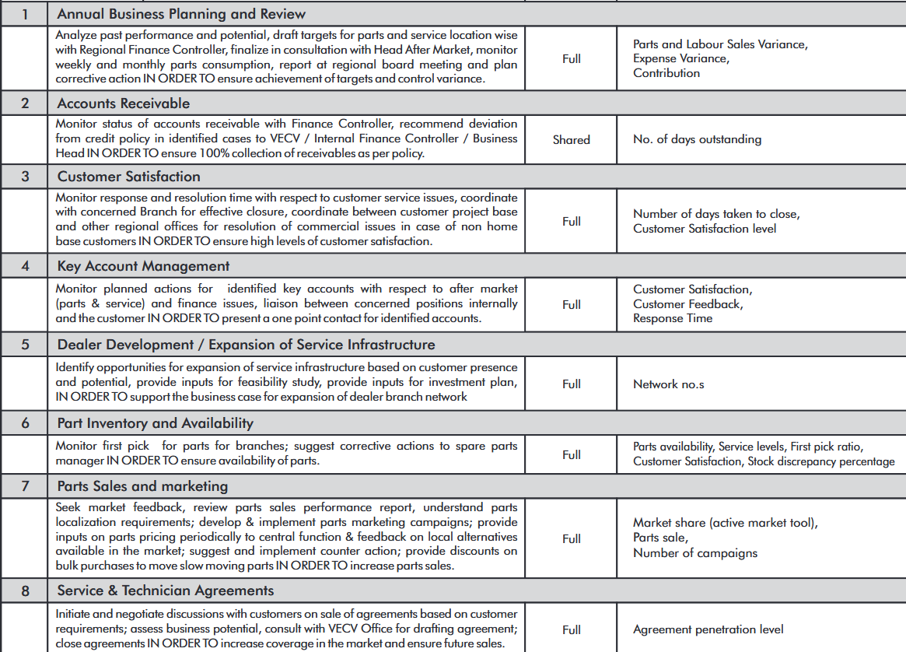

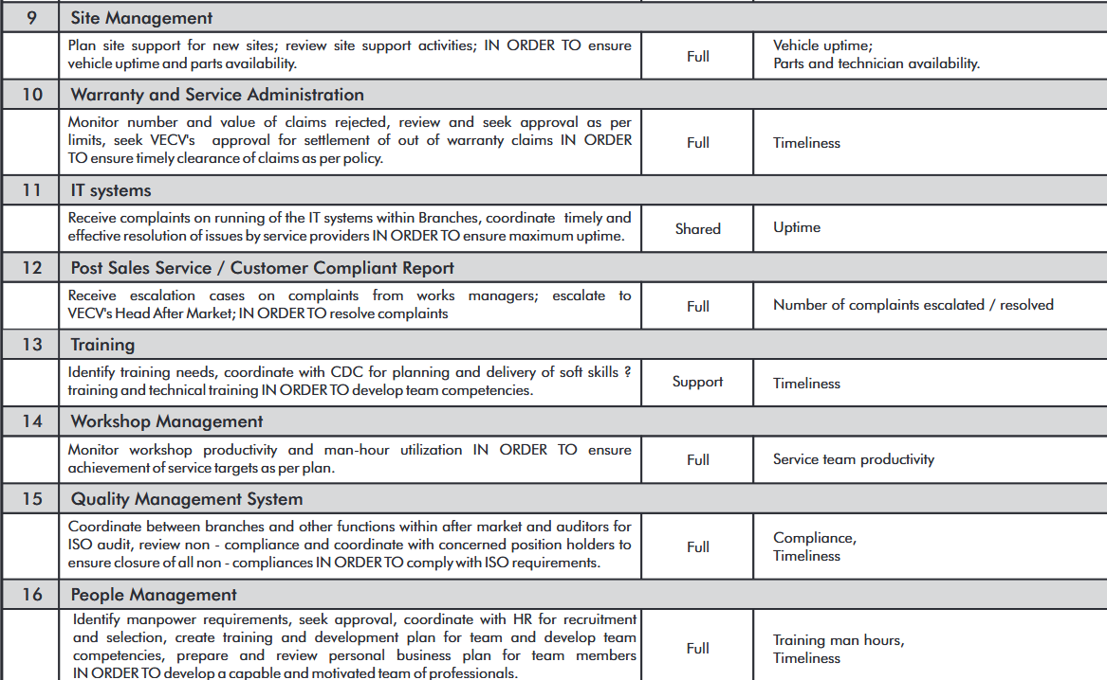

5-Praxair India Private Limited (Merged with Linde India Pvt Ltd)

Tenure: June 2016 to April 2023 (6.10 Yrs) Designation: Regional Fleet Manager (North & Central India)

Location – Raipur (chattisgad)

Accomplishments:

* Successfully implemented project related to GPS devise & Fuel sensors/Fatigue Monitoring system/mobile digital recording devise installation based on project delivery schedules and other SLA parameters.
* Successfully implemented Trailer Suspension Upgradation Projects. (Mechanical to Pneumatics)
* Pay Load Optimization of the tankers as per the revised GVW Structures.
* Successfully implemented new Fleet Management ERP followed by PAN India Staff Trainings across various Locations.
* Rewarded Best Productivity & technology implementation award for the Fuel savings & the Trailer Electronic Braking system.

Key Profile:

Operations Management

* Spearheaded team efforts in ensure seamless movement of 80 Cryogenic Semitrailers and 20 rigid axle Tankers, across northern, & central Part of India for about 140 Customers which Carries the Liquid Products of Oxygen, Nitrogen & Argon.
* Management reports (Liquid movement planning, Plan Vs dispatch, delivery window to reduce transit time, P&D analysis (particularly during shut down of plant).
* Productivity initiatives (increasing drop size, scheduled maintenance of tanker (vehicle) to reduce time of tanker, identifying VITT with higher loss for maintenance)
* All India tanker and truck Management - Daily / weekly transport planning and scheduling, trip-turnaround, transits time and planning track and trace and logistics network planning.
* Involvement with sales and CES for giving vital inputs as to the size of VIST at customers end & Implementation of regular customer feedback of customer grievances at the Earliest.
* Monitoring vehicle utilization parameters - payload utilization, Fill Gap, Return Loss and Transit loss etc.
* Vehicle Detention monitoring at customer and owned units.
* Handling of Regional Own Maintenance Facilities (availability of spares, lubes, manpower & other basic entities).
* Responsible for Regional R&M, Tires, Statutory Cost reviews as per the plan & handling INR 1.5 CR/Year.
* Responsible for on time PR-PO-Payments to the concerned Vendors for Fleet Maintenance & Transporters.
* Coordinated with the senior management in maintaining organizational P&L by finalizing distribution & transport operations & maintenance budget for logistics & fleet department.
* Partnered with sales operations & finance departments in defining & implementing annual fleet operating plans based on changing market dynamics and other related factors.
* Interacted with customers for collating & evaluating requirements and rendering customized solutions. Enhance client satisfaction by effectively resolving issues and rendering superior quality service.
* Enhanced operational efficiency by designing fleet organization structure, competency mapping, developing career progression plan, defining job description, roles and responsibilities & Key deliverables.
* Liaised with HR for recruitment, grooming & mentoring team members as well as organizing training sessions based on identified skill gaps and business requirements.

Logistics & Procurement

* Coordinated activities related to procurement, deployment and phasing out of fleet based on AOP. Interacted with IS/IT team in maintaining seamless operations and maintaining SAP & Other ERP tools.
* Worked on evaluation & standardization of fleet encompassing planning, procurement, leasing of existing fleet based on business requirements.
* Designed & fabricated new fleet based on transportation modes, product range and demographic requirements.
* Followed up with vendors & suppliers for maintaining updated inventory of spares for the automobile workshop to cater to exigent situations.
* Managed day to day activities at the workshop aimed at cost optimization and enhancing asset uptime by guiding team members in ensuring compliance to OTM and process flow.

Reporting & Compliance Management

* Acquainted team members with organizational policies & procedures as well as other statutory regulations for implementing the same in day-to-day business transactions.
* Interacted with the Road Transport Authority and Municipality for securing necessary permit and certificate pertaining to the fleet.
* Focused on implementation & compliance to company Health and Safety policy in transport department to eliminate potential operational hazards.
* Followed up with internal & external stakeholders in ensuring compliance to client SLA and other contractual parameters pertaining to day-to-day operations.
* Highlighted critical technical issues and other operational issues with potential business & revenue impact to the senior management for implementing effective remedial measures.
* Updated business status to the senior management and other stakeholders using detailed reports and presentations to enable effective decision making.

4 -Hindustan Coca-Cola Beverages Pvt Ltd, Bangalore – India

Tenure: Dec 2011 – May 2016 (4.6 Years)

Designation: Unit Fleet Manager

Location : Bidadi - Bengaluru

Accomplishments:

* Generated saving of 15% effectively implementing Six Sigma / LEAN projects for Fuel management and Preventive maintenance programs.

Key Profile:

* Handled Mix Fleet Size of 120 Trucks (Eicher & Tata 2 MT to 49 MT Trailers)
* Prepared & implemented fleet budget & AOP to align with organizational sales plans & objectives for the Karnataka zone. Optimized & aligned maintenance cost & fuel cost per case to budgeted figures for achieving budgeted P/L.
* Collaborated with various support teams in managing fleet procurement, body fabrication and deployment as per AOP. Assessed & aligned fleet profile to changing business requirements and other statutory regulations.
* Followed up with vendors for maintaining updated inventory of spare parts to cater to exigent situations and maintain seamless operations.
* Coordinated activities related to renewal of statutory certifications for the fleet as per RTA guidelines as well as implementing company's EHOS policy for the Fleet department.
* Implemented effective remedial measures based on root cause analysis of accidents. Customized & set up CMMS ERP for fleet maintenance Transactions.
* Conducted training sessions for fleet users on defense driving based on organizational policies and procedures.

Previous Assignments



3-TVS Sundaram Motors - Authorized Dealer for Chevrolet Cars (General Motors)

Tenure: July 2010 to Nov 2011 (1.6 Years)

Designation: Junior Technical Officer.

Location : Bengaluru

Key Profile:

* Organize & manage proper functioning of workshop.
* Investigation of major and minor parts filing within warranty and post warranty period.
* Providing technical guidance, especially in terms of warranty decisions and troubleshooting.
* Personally carryout random inspection of customer vehicle attended in workshop to ascertain quality of service.
* Monitoring product performance of Fleet/Key operators.
* Monitor & Improve Vehicle redemption, C.S.I.
* Release monthly-consolidated report to the Management regarding summary of jobs attended in the month revenue achieved vis a vis target.
* Coordinate with Principals of GM Motors Ltd., regarding field failure and product performance.
* Coordinate with proprietary parts dealers/service centres.
* Coordinate with other OEMs regarding failures and modifications.
* Coordinate with spare parts departments for maximizing service volume efficiency and profit.
* Equip workshop with all necessary tool, equipment and infrastructure.
* Conducting regular meetings of service personnel and encourage quality circle activity to improve work efficiency.

2-Lathagi Automobiles private Limited – Bangalore (VOLVO Bus Dealer) – India

Tenure: June2008 to June 2010 (2 years)

Designation: Service engineer & warranty Admin

Location : Bengaluru

* Attending Vehicles (Buses & Trucks) for scheduled service & running repairs & allotment to the Technicians.
* Responsible for Making Technical failure report on various components & availing the approvals from VOLVO tech support).
* Timely follow ups with Shop floor, store & with customer to ensure on time delivery to the customers.
* Promote dealer service benefits to potential customers.
* Planning>Organising>Leading & control workshop Management Operations.
* Taking care of service agreement claims for KSRTC & BMTC Buses.
* Taking care of warranty issues, arranging spares, audits & getting the on-time credit note from VOLVO.
* Job card opening, closing & invoicing & preparing the same for the Internal audit as well.
* Investigation of major & minor components which are failing within the warranty & post warranty period.
* Training Calendar for technicians & giving them the latest features introduced by VOLVO.
* Monitoring workshop efficiency & Mechanics productivity In order to Increase the revenue of the workshop.
* Addressing Enroute Breakdown Calls 24x7.

1-Concorde Motors Ind Pvt Limited – Bangalore (Tata Passenger Car Div) – India

Tenure: June2007 to May 2008 (11 Months)

Designation: Warranty Executive

Location: Bengaluru

Key Profile:

* Giving feedback about newly launched vehicles. (Frequent complaints & performance).
* Handling & resolving product failures, collecting feedbacks from the technicians & operators.
* As a warranty officer, obeying TATA Motors Warranty Policy and Procedures.
* Diagnosing customer concerns & giving guidance to solve problems to the technicians.
* Taking care of all warranty claims uploading through online system.
* Conducting Free check-up camps & sending campaign report to TATA Motors.
* Instructing technicians to follow Service standard procedures & usages of special tools
* Giving systematic suggestions to manufacture, how to resolve product related complaints
* Warranty activities and extended warranty follow up.

Academics



* Diploma in Automobile Engineering, State Board of Technical Education, Bangalore
* Pre-University course (+2) from PU Board Bangalore.
* SSLC from Karnataka secondary board Bangalore

Professional Enhancement



* Training from TATA motors on new models and emerging technologies.
* Customer handling & Telephonic conversation.
* Warranty & service agreements Training in VOLVO India Pvt Limited.
* B7R & B9R Buses & FM series Truck training in VOLVO India Pvt Limited.
* Training on white collars & technical orientation in VOLVO India pvt Limited

System Proficiency



* Siebel portal Transactions.
* LDS (Local dealer Management)
* FMS (Fleet Management software).
* JDE
* SAP

Personal Details



|  |  |
| --- | --- |
| Father Name | Yallappa B Pujar |
| DOB & Age | 10th of June 1985 (40 Yrs.) |
| Languages Known | English, Hindi & Kannada |
| Marital status | Married |
| Contact No & Email Id  Joining availability | 9620115107  ([Pujar22ravi@gmail.com](mailto:Pujar22ravi@gmail.com))  30 Days |

I Hereby declare that the above furnished Information is genuine and accurate to the best of my knowledge & belief.

Place: Hubli Your Sincerely

Date: Ravi Pujar