Curriculum Vitae
Rajeev Goel 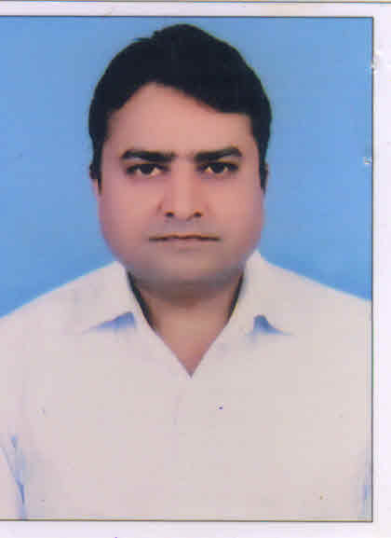
Flat No. 202, 187/188 Tilak Park,
Sadar, Meerut – 250 001
Mob : +91 9639445500, Email ID: rajeevgoel0009@gmail.com

Career Objective
To be an accomplished professional in the area of Accounts and Finance by using my learning, knowledge and experience effectively and efficiently with an organization having professional set up.

Current Employer
Organisation : Tanya Automobiles P. Ltd.(Maruti Dealer) Meerut.
Designation : Senior Accountant
Experience : Since March 2023 till Date

Job Profile
- Review of Monthly sub ledgers of MUL and review the each and every payout received from MUL and compare with the Schemes applicable.
- Co-ordination with Warranty Manager and review the Warranty Claims status and ensure that all the lots being generated.
- Co-ordination with Body-Shop Insurance Claim Manager and review the outstanding on Insurance companies.
- Co-ordination with Spare Parts Manager to review PNA List and Non-Moving Stock Items.
- Co-ordination with MUL officials for discrepancies in Sub Ledgers, if any.
- Co-ordination with Finance Manager for timely receiving of Payouts from Banks and NBFC’s
- To ensure timely issue of invoices (viz. CCP Commission, CRI Commission, EW Commission etc) to MUL.
- Tracking of Payment from MUL regarding each and every claim
- Co-ordination with True Value GM for monitoring on submission of docs with MUL for the vehicles under Exchange.
- Monitoring on Payment towards Free Service Coupon.
- To prepare monthly P&L for each branch.

Last Experience
Organisation : Jai Kumar Arun Kumar (Mahindra & Mahindra Dealer) Meerut.
Designation : Accounts Manager
Experience : December 2019 to March 2023
Job Profile
- Daily Bank Reconciliation and ensure Card Swipe payments received from Bank.
- To ensure GST, Cess and TCS are properly applied on sale of vehicles.
- To ensure payments are received from Renewals of Insurance.
- Month end Reconciliation with Mahindra to ensure Warranty and other Claim are settled.
- Monitoring on Workshop Debtors and follow-up thereof.
- To ensure timely deposit of TDS and GST and submission of Returns thereof.
- Monthly MIS preparation.
- Finalization of Accounts.

Organisation : Tanya Automobiles P. Ltd.(Maruti Dealer) Meerut.
Designation : Finance Manager
Experience : Februaty 2012 to December 2019
Job Profile
- Co-ordination with Branch Managers of Financiers (i.e. HDB Finance, Cholamandalam, ICICI Bank etc.) for smooth disbursement of Finance Cases.
- Assisting the Finance Executives for to match the best deal.
- Month end preparation of Finance Report. Follow up with Financiers for payout.

Organisation : Digi Cable Network (India) P. Ltd. (Cable Distribution Co.) Delhi.
Designation : Site Finance Controller
Experience : Februaty 2008 to January 2012

Job Profile
- Statutory compliance: Service Tax, TDS Payment, and Entertainment Tax.
- Bank Reconciliation Statement.
- P/L Account (MIS) finalized and sent to HO by 5th of every month.
- Inter company reconciliation
- Debtors Collection.

Organisation : Perfect Marketing P. Ltd. (Crompton Distributor) Ghaziabad.
Designation : Accountant
Experience : April 1997 to February 2008

Professional Qualification
Articles Training (Institute of Chartered Accountants of India) of 3 years completed on May 1997 under Arora Rajesh & Co., Ghaziabad.

Academic Qualification
B.Com. (Pass) from D.N. College, Meerut in 1992.
Intermediate from St. Joseph Inter College, Meerut in 1989.
High School from St. Joseph Inter College, Meerut in 1987.

Exposure to Computer
Windows, ME 2000, Windows XP. Tally Prime, Tally ERP 9. Tally on cloud.
MS Word, MS Excel.
English typing speed approx @ 40 wpm.

Personal Information

Date of Birth : 17th July 1972
Father’s Name : Late Sh. R.C. Goel
Permanent Address : Flat No. 202, 187/188 Tilak Park, Sadar, Meerut – 250 001
Marital Status : Married
Languages Known : Hindi and English
Driving License No. : DL-0420110157720
Passport No. : J6736915
PAN : ACNPG6113B

Rajeev Goel
Date :
Place :

