**CURRICULUM-VITAE**

MOHAMMAD QASIM SIDDIQUI

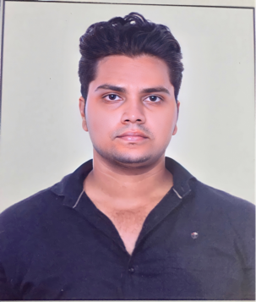77B/3K, Ekram Nagar,

Ainuddinpur, Kareli

District- Allahabad-211016

Contact no: +91-7571835739, 9580627443

Email- luckyazmi11@gmail.com

**CAREER SUMMARY**

Looking for a long association with an organization where, individual skills, talent, honesty and hard work are acknowledged and a conducive work environment is provided.

**EDUCATIONAL QUALIFICATION**

* High School from Benhur High School & College, Allahabad in 2014
* Intermediate from SMT. K.P. Public School, Allahabad in 2016
* B.Sc. from Allahabad State University, Allahabad in 2019

**EXTRA QUALIFICATION**

* Microsoft Office
* Intermediate Knowledge of Computer

**PROFESSIONAL EXPERIENCE**

* Experienced 2 years as a ‘Front Office Executive’ at a Public Transport Company.
* Experienced more than a year as an ‘Information Retrieval Officer’ at Justdial, Noida.

**RESPONSIBILITIES**

* Greeting guests and assist them with walk in & walk out.
* Maintain a positive attitude and friendly manner.
* Communicate customer’s requests to management.
* Any other tasks as assigned from time to time given by management.

**sTRENGTH**

* Punctual & Honest
* Hardworking
* Improving skill with self motivation
* Flexible
* Reliable
* Ability to learn quickly
* Ability to work as an individual as well as a team
* **Strong Communication Skills**

## PERSONAL INFORMATION

**Name :**  Mohammad Qasim Siddiqui

**Date of Birth :** 08-May-1996

**Nationality :**  Indian

**Languages Known :** English, Arabic & Hindi

**Gender :** Male

## DECLARATION

I solemnly declare that the above information is true and correct to the best of my knowledge. I understand that if any information given above is found false/incorrect, I am liable to be rejected.

**(Mohammad Qasim Siddiqui)**

**Date-**

**Place- Delhi**